**Pre-Lab 4 Report**

Part 1: Clock Generator

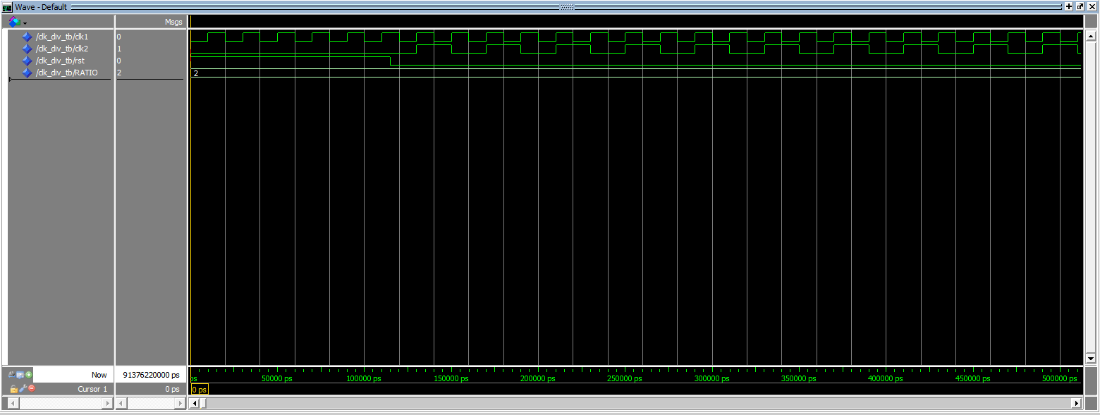

Part 2: Gray Counter 1

Part 3: Gray Counter 2

Part 4: Up/Down Counter with Load (Zoom In)

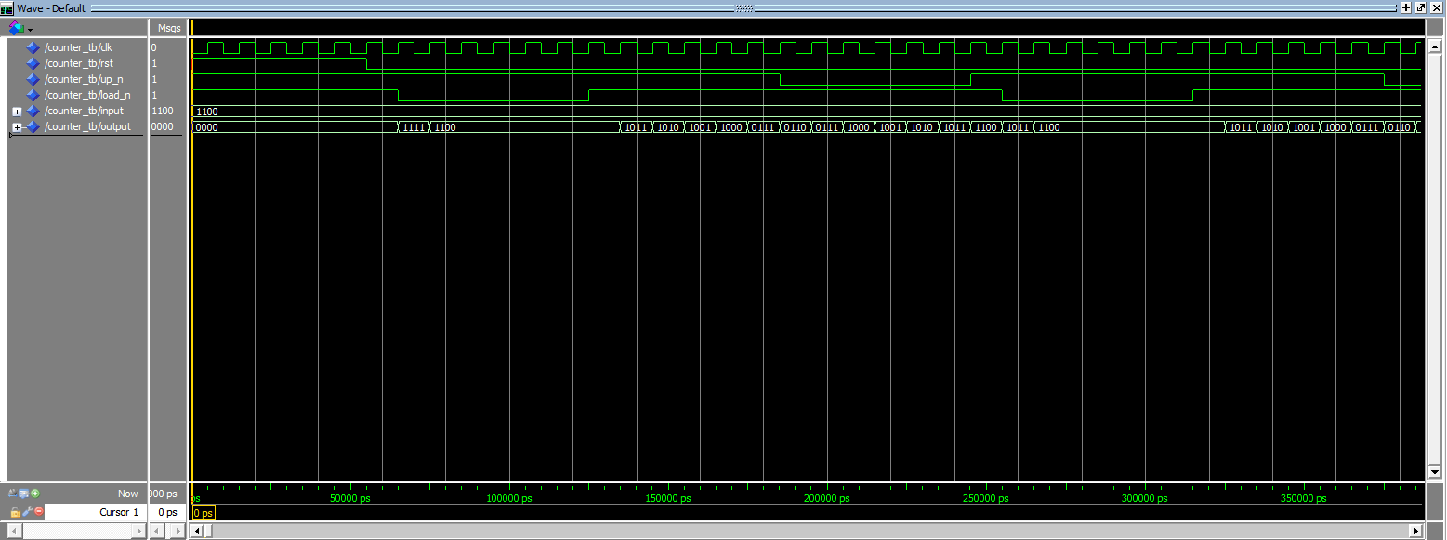

Up is now 1, so it starts to count back down

Load goes to 1 and 1100 is loaded again

Load had to wait for the next rising clock edge, but is 0 so it is loaded with 1100

Up is now 0, so it starts to count back up

Load is 1 and up is 1 so it counts down to 1011 and so forth

RST is 0 and up is 1 so it counts down to 1111

RST is 1 so the output is 0000

Part 5: Top Level Description

The top level entity is using the clock to clock the counter and gray code counter. The two counters are outputted to wo of our seven seg displays. The first 4 switches are used for the input load, the next is used to toggle up or down, and next is used to load the input. The top button is used for the clocking.